**Word of Life: May 2022**

*Recommended dates are provided, but you are welcome to use these materials at any time!*

**Featured this Month…**

**May 8, 2022: Mother’s Day**

Mother’s Day is a wonderful opportunity to highlight the beautiful vocation of motherhood and the gift of life.

Our [Mother’s Day action guide](https://www.usccb.org/resources/respect-life-action-guide-mothers-day) features homily considerations, intercessions, activity ideas, and more to assist with honoring and praying for mothers in your parish community.

A [webinar recording](https://youtu.be/1QQdhfON3Ww) of USCCB staff walking through the materials, as well as [the presentation slides](https://www.usccb.org/resources/respect-life-action-guide-mothers-day-webinar-slides), are available.

\**You’re welcome to use one component of the action guide or the whole thing—whatever’s helpful!*

**May 31, 2022: Feast of the Visitation of the Blessed Virgin Mary**

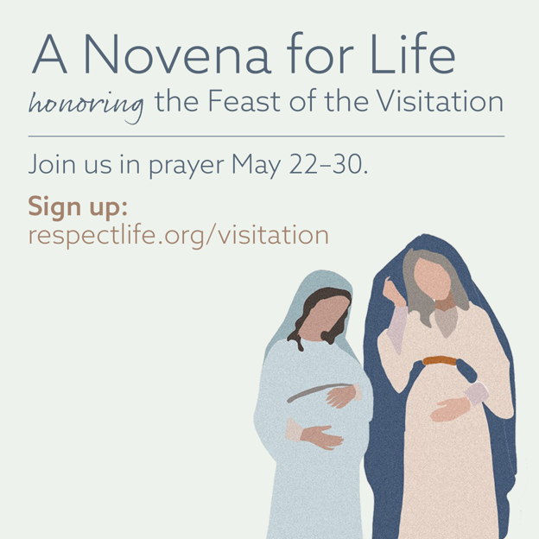On May 31st, the Church celebrates the Feast of the Visitation of the Blessed Virgin Mary. This feast commemorates the Blessed Mother’s visit to her cousin Elizabeth and the encounter of Jesus and St. John the Baptist while in the wombs of their mothers. Join us in praying [A Novena for Life](https://www.respectlife.org/visitation) in honor of this special feast day.

**Suggested Date for Graphic/Announcement:** Weekend of May 14-15, 2022

[**Download Graphic**](https://www.usccb.org/resources/visitation-novena-life-graphics)

**Sample Announcement:**

*Join A Novena for Life honoring the Feast of the Visitation. Sign up at* [***respectlife.org/visitation***](http://www.respectlife.org/visitation)*!*

**Word of Life – May 2022**

**Intercessions for Life**

|  |  |
| --- | --- |
| **May 1st**  For persons with disabilities:  May their lives always be recognized  as worth protecting and fighting for  in all circumstances;  *We pray to the Lord:* | **Third Sunday of Easter** |
| **May 8th**  For all mothers: That they may be encouraged and supported  as they live out this special vocation; *We pray to the Lord:* | **Fourth Sunday of Easter** *(Mother’s Day, which is not a liturgical feast but is often recognized at Mass)* |
| **May 15th**  May the Holy Spirit strengthen God’s people  to embrace and protect  the precious gift of human life;  *We pray to the Lord:* | **Fifth Sunday of Easter** |
| **May 22nd**  May the Supreme Court act to restore  legal protection for the lives of unborn children  by overturning the tragic decision of *Roe v. Wade*;  *We pray to the Lord:* | **Sixth Sunday of Easter** |
| **May 29th**  For all Christians:  That our example may give witness to  the precious gift of human life in this world and  the invitation to eternal life in the next;  *We pray to the Lord:* | **Solemnity of the Ascension of the Lord**  **(or the Seventh Sunday of Easter where applicable)** |

**Word of Life – May 2022**

**Bulletin Quotes**

|  |  |
| --- | --- |
| **May 1st**  “Even the weakest and most vulnerable, the sick, the old, the unborn and the poor, are masterpieces of God’s creation, made in his own image, destined to live forever, and deserving of the utmost reverence and respect.”  USCCB Respect Life flyer quoting Pope Francis’ “Day for Life Greeting”  © 2013 Libreria Editrice Vaticana. Used with permission. All rights reserved. | [Download](http://www.usccb.org/about/pro-life-activities/respect-life-program/upload/Flyer-RLP2014-Color.pdf) |
| **May 8th**  “O Blessed Mother, you received the good news of the incarnation of Christ, your Son, with faith and trust. Grant your protection to all pregnant mothers facing difficulties.”  USCCB Secretariat of Pro-Life Activities, “A Prayer for Pregnant Mothers” | [View, Download,  or Order Prayer Cards](https://www.walkingwithmoms.com/prayer-for-pregnant-mothers) |
| **May 15th**  “Everyone is in need of reassurance, and if we, who have touched ‘the Word of life’ (1 *Jn* 1:1) do not give it, who will? How beautiful it is to be Christians who offer consolation, who bear the burdens of others and who offer encouragement: messengers of life in a time of death!”  Pope Francis, [2020 Easter Vigil Homily](http://w2.vatican.va/content/francesco/en/homilies/2020/documents/papa-francesco_20200411_omelia-vegliapasquale.html)  © 2020 Libreria Editricea Vaticana. Used with permission. All rights reserved. | |
| **May 22nd**  “The tragic U.S. Supreme Court decision of *Roe v. Wade* has allowed for the destruction of millions of innocent lives through legalized abortion. The Supreme Court is now in the process of deciding a case that has the potential to weaken, or even overturn, *Roe v. Wade*. As the Court prepares to release its decision in *Dobbs v. Jackson Women’s Health Organization*, Christians across the country are uniting in prayer for this important case. Society as a whole must respect, defend and promote the dignity of every human person, at every moment and in every condition of that person's life. May we commit ourselves to urgent prayer and fasting, that the Court may act to uphold the dignity of unborn human life.”  USCCB Secretariat of Pro-Life Activities, Respect Life Prayer Guide | [Download](https://www.usccb.org/resources/rlpa-22-02-prayer-guide-rev.pdf) |
| **May 29th**  “The Lord says to us, ‘Do not fear: I am with you’ (Isaiah 41:10). He speaks these words not as one who merely observes our pain, but as one who experienced immense suffering. And the very wounds that bear witness to his suffering indicate the essence of our identity and worth: we are loved by God. Reflecting on the healed wounds of the Risen Christ, we see that even our most difficult trials can be the place where God manifests his victory. He makes all things beautiful. He makes all things new.”  USCCB Secretariat of Pro-Life Activities, “Be Not Afraid” NABRE © 2010 CCD. Used with permission. | [Read](https://www.respectlife.org/be-not-afraid) | [Download](https://www.usccb.org/about/pro-life-activities/respect-life-program/2017/upload/rlp-17-reflection-flyer-single-english-color.pdf) |

**Word of Life – May 2022**

**Bulletin Art**

*You are welcome to use these images, provided they are not altered in any way, other than the size. Thank you!*

**Sunday, May 8th, 2022**

[**Download Image**](https://www.usccb.org/resources/respect-life-action-guide-mothers-day-activity-graphic)

**Spiritual Bouqet Activity Instructions:** Select “Activity (with at-home option)” from the list of documents on [this page](https://www.usccb.org/resources/respect-life-action-guide-mothers-day).

**Sunday, May 15th, 2022**

*(The Feast of the Visitation of the Blessed Virgin Mary is Tuesday, May 31st.)*

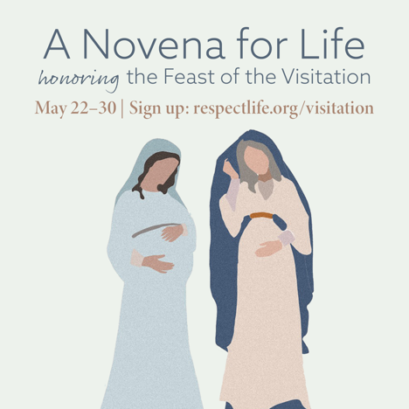

[**Download Image(s)**](https://www.usccb.org/resources/visitation-novena-life-graphics)

**Sample Announcement:**

*Join A Novena for Life honoring the Feast of the Visitation. Sign up at* [***respectlife.org/visitation***](http://www.respectlife.org/visitation)*!*

**Sunday, May 22nd, 2022**

**Download:** [English](https://www.usccb.org/sites/default/files/2022-02/rlpa-22-02-prayer-graphic.png) | [Spanish](https://www.usccb.org/resources/rlpa-22-02-prayer-graphic-spa.png)

**More:** [***Dobbs* Parish Kit**](https://www.usccb.org/resources/word-life-special-edition)